**Operators**

Hi, PPTI 16 fellows. Welcome to COMP6047001 – Algorithm and Programming second session! In purpose to practice after learning the material of many Operators, here is the case that you need to solve.

When the program has been run, here’s the program flow that you need to create:

* In the beginning of program’s execution, the program ask user to **input** their favorite number. We can call the number as $x$.



**Figure 1 input favorite number (x)**

* Then, **print** the result of number with formula below.
  1. Result 1 = $2x+3$
  2. Result 2 = [Result 1]/3 – 4
  3. Result 3 = [Result 2]2 🡪 **\***Try to use **shorthand operator** here**\***
* Then the program will assign **pointer $y$** with the value of $x$. Then it will print 2 results from the value of **pointer $y$** . Here are the two results:
  1. If $y$ $≥$**10** then print **“Y is bigger or equals 10”**. If $y$ $<$**10** then print **“Y is smaller than 10”**.
  2. If **y is odd number,** then print **“Y is odd”**. If **y is even number**, then print **“Y is even”**.

* You can search about **Ternary operator** to solve this*

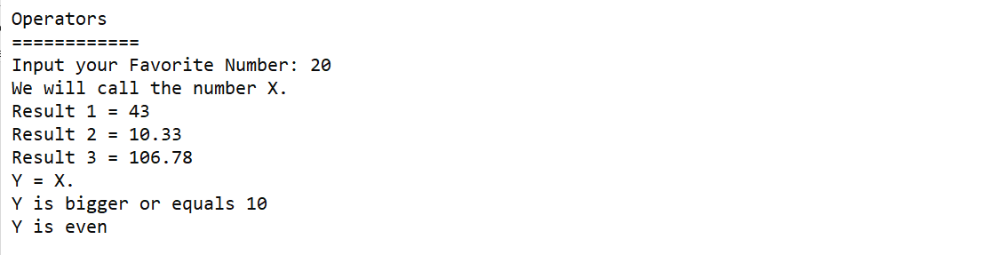

**Figure 2 Output Example**